How to connect biometric device with our Access control

Now, many customers get a problem that how to connect biometric device ( such as finger reader ,facial device etc) to controller and how to operate in the software.
Now let’s introduce how to connect biometric device with our access controller by example as finger reader:
This solution also suitable for how to connect facial recognition to controller.
Here’s the solution
1、Connection fingerprint card reader with Access Control
The default output of Fingerprint reader is wiegand 26 bit. so there has connection the cables with d0 , d1 ,GND for access control!

Generally that is better to use the power supply with fingerprint card reader , because of sometimes the controller will have not enough current flow to support fingerprint card reader.
2、Operation between fingerprint card reader and access controller
Only users registered on finger reader can output wiegand 26 bit , otherwise can’t..
Generally , the default wiegand output format is device No. + register No. then you can register card No. in access controller software.
For example：the fingerprint device No. is 1, and the user register No. is 100,so the appeared No. is 100100 on the Access Control software , then you assign privilege to this user , finally the user registered on fingerprint card reader can open the door.
There is two ways to see the Wiegand output format how to appeared on access controller software:

First one: click add by reader 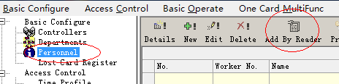

Second one: click monitor
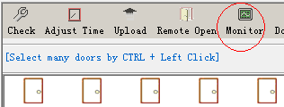
You can see the fingerprint wiegand output format on access controller software through these two ways.

