How to do OEM software

You can do OEM software CD with your company own Logo ,company name , then you need make CD by yourself then sent to your customers !
Notice : Never run the files under the catalogue of copy ！！！

Open the software CD , copy all the files to other catalogue of disk

Step 1 : Replace company Logo

The company logo photo file is named as “aboutlogo.jpg”
Under “zh-CHS”
Pixel: 145*145
The logo photo appears in the menu “help/about”
The new logo photo should be renamed exactly to “aboutlogo.jpg”, and format should be jpg; Pixel should be 145*145. just copy the new logo photo into “zh-CHS” and replace the old one.
For example as :

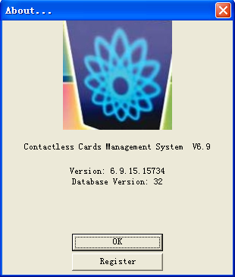
After replacement, example：
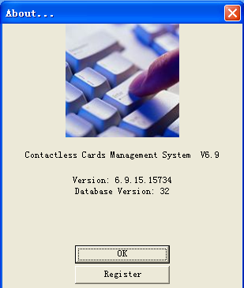

Step 2: Change the background interface photo
Under zh-CHS, file named as “backImage.jpg”, pixel: 1500*700


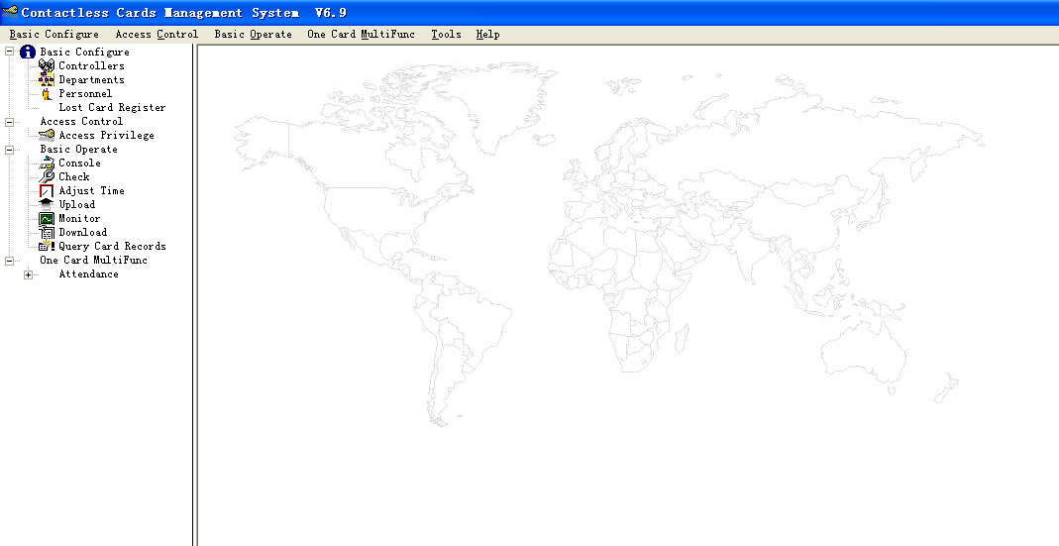

After replacement, example:

Step 3:Change the log in interface pic
Under zh-CHS, file “loginImage.jpg”, pixel:313*209
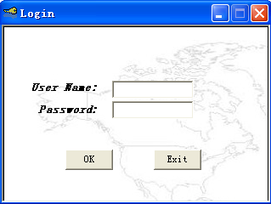
After replacement, example:

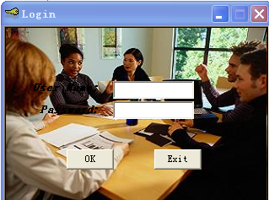

Step 4: Change the title text of the main interface:
Open the database”iccard.mdb”which is under the folder “en” ,
Database password is 168168
Open the data sheet t_a_SystemParam
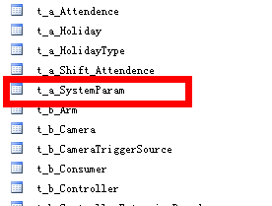
Step 5 : hange the “f_Value” which is in the row of 17th
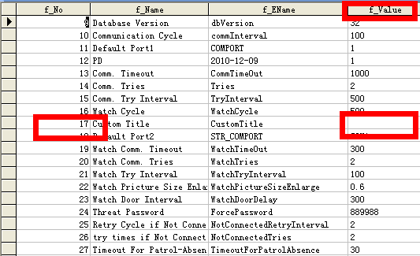
For example, input “Wiegand Access Control”.
But there can be no more than 25 characters .
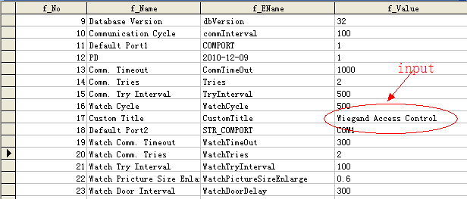
Step 6 :
Save the Database and exit, copy the iCCard.mdb into zh-CHS\Style, and delete the default file iCCard_Default.mdb, then rename the iCCard.mdb as iCCard_Default.mdb.
When all is done,the OEM version is ok.
Now,let’s have a look the tile before change:

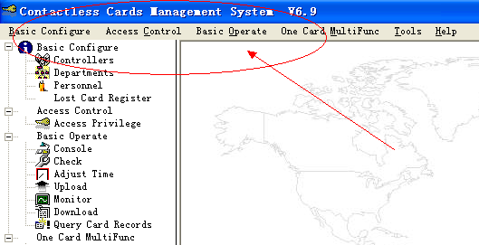

After change :
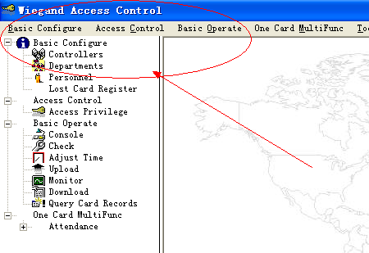
Step 7 : Burn Disc
Use Nero or other software for Burn Disc
Select all the files and burn them.

