Preparation
1. Connect：Please connect the Access Control to PC with net cable (by HUB or Switch).

2. Check the LED of Controller：
light RX/LINK on, indicate working normally.
Light RX/LINK off, indicate failed connection. please check the network connection.
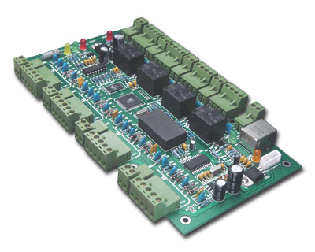
RX/LINK Light
TX Light
Notice：Please close the firewall if your computer have installed it。
If your operation system is windows xp, pls close its firewall.
- If all the Access Controls are spread with Small LAN ,please reference chapter 1;
- If Access Controls are spread in medium size LAN with different segments ,please reference chapter 2 ;
- If users want to visit the controller via Internet please reference chapter 3;

Chapter 1 Small LAN in same segment
All controller and computer work in same segment of small LAN , operation as follows ：

1. Search Controller for test
Click Basic setting ------ Controller
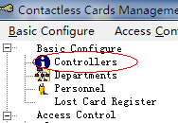

Click 【Search.Net】
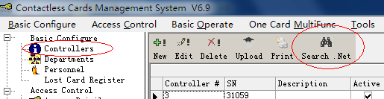

Such interface appears if the searching controller successfully
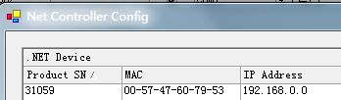
Click 【Search】 Button，to refresh the search result;

Notice：If searching failed，means these controllers failed to connect with LAN ,please check the reason as follows :
1. Pls check whether the firewall closed, if not, close it.
2. Pls check whether the net cable in good condition, if not, change a new one.

2. Add Controller
Click 【Basic Setting】 --- 【Controller】 ---【Add】 Please reference interface as follows :
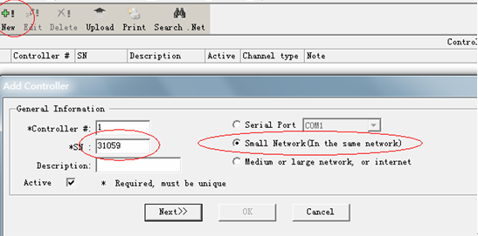

Notice：fill in the series number of controller displayed as S/N on board
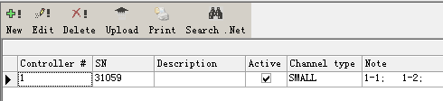

3.Check the communication between Access Controller and Software。
【Basic Operation】--【Console】--- 【Check】
- Working normally shows as green : 。
- Failed communication shows as red: ，

Chapter 2 Medium size LAN with different segment

Applications description
Controller and computer are spread in different segment. Computer in one segment and controller in another segment.
Solution as follows:

1. Search Controller in same segment. The steps pls reference chapter 1.

2. Setting Controller IP Address
In the search interface, selected Controller which one want to be set IP Address (the ip address is in another segment ,not the same with computer),click 【edit】or double click. :
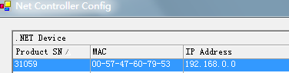
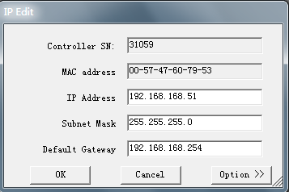
Fill in the new IP Address， click 【ok】.
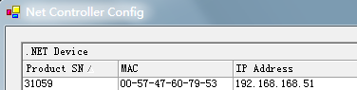

After that , the controller IP Address with S/N：31059 changes as 192.168.168.51,
But your computer is not in 168 segments.
Then put the controller in 168 segment network.
You can ping controller IP address ,if through, you can add controller to software and manage it.
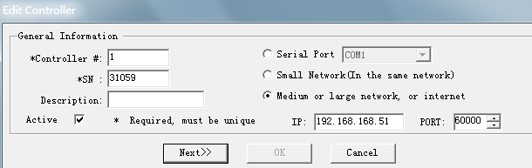
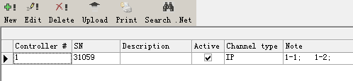

Chapter 3 Internet Setting
Users Visit Controller via the Internet, just for a dynamic domain name or a static public IP. Then you can manage controller via internet.

Essential Condition
1．Set controller ip.
2. Need a router, the router support port forward.
3. Apply for a domain name, usually the ADL distributed is a dynamic IP.

Set controller ip, pls reference chapter 1.

Open router interface. Set port forward to controller ip. the controller default port is 60000, you surely can change it .
Apply for a dynamic domain name from domain website.
After this, you can add the controller to software and manage it.
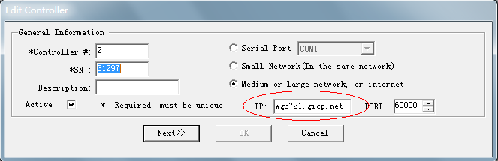
Wg3721.gicp.net is a domain name we applied for from domain website.

After steps, you can see the settings are successful.
